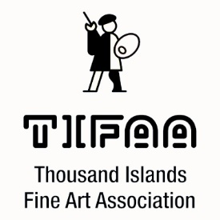

2023 TIFAA EXHIBITOR AGREEMENT

Artist’s Name:
Address:
Postal Code:
Telephone: (Res) (Cell) Email:

ARTIST’S AGREEMENT

I understand and agree to the following terms for the display and sale of my work:
- TIFAA assumes no responsibility for loss, theft, or damage to my work, or for money owed for sold works.
- The sale price of my work is subject to a commission of 17% which covers credit card fees (if applicable) and exhibition overhead (labels, wrapping, signage, advertising, etc.) plus Square charges.
- I am an independent contractor, personally responsible for any applicable taxes on my sold works.
- I will abide by all decisions of the TIFAA Show Committee/ Executive regarding exhibition operations and by any decisions of the curators as regards the quality and/ or appropriateness of my works for display; as well as how and where they are hung in the exhibition, although the curators will endeavour to ensure that all hanging artists have equal access to perceived “better/prime” locations.
- I will not remove works from display for use in other venues without the approval of the Show Committee/ Executive for the duration of the exhibit.

Artist’s Signature:

Date:

